

Capstone Project Phase B

**The tool for computational simulation the Earth Energy Absorption**

**24-2-D-39**

**Students:**

Haya Kabishi 211582978 - [Haya.Kabishi@e.braude.ac.il](mailto:Haya.Kabishi@e.braude.ac.il)

Daniella Kadmany 314701699 - [daniella.kadmany@e.braude.ac.il](mailto:daniella.kadmany@e.braude.ac.il)

**Supervisor**:

Dr. Zakharia Frenkel

[**GitHub**](https://github.com/HayaKabishi531/Final-Project-24-2-D-39.git)

Table of contents

|  |  |
| --- | --- |
| Table of Acronyms | 5 |
| **Abstract** | 6 |
| **1.Introduction** | 6 |
| **2.Background** | 7 |
| 2.1.This research focuses on some key parameters critical to understanding energy absorption and distribution in natural systems | 7 |
| **3.Climate change throughout history** | 8 |
| 3.1.Temperature change: | 8 |
| **4.Earth's Energy Budget** | 9 |
| 4.1.Incoming and Outgoing Radiation | 9 |
| 4.2.Role of the Atmosphere and Surface | 9 |
| **5.Incoming solar radiation** | 10 |
| 5.1.Impact of Incoming Solar Radiation on Climate and Energy Budget | 10 |
| 5.2.Climate system as heat engine | 11 |
| **6.Available Data** | 12 |
| 6.1.Key parameters solar data and Climate Feedback | 12 |
| 6.1.1.Solar and Atmospheric Energy | 12 |
| 6.1.2.World Ocean | 12 |
| 6.1.3.Atmospheric Dynamics and Climate Feedback | 13 |
| 6.2.Existing Data integration and modeling | 14 |
| **7.Research process** | 15 |
| 7.1.Earth division and Area calculation | 15 |
| 7.2.Energy Absorption Calculation | 15 |
| 7.3.Purpose of the comparison | 15 |
| 7.4.Data Processing | 15 |
| 7.5.Validation and Results | 16 |
| 7.6.Final Energy Calculation | 16 |
| **8.Dataset** | 17 |
| 8.1.Parameters from ERA5 | 17 |
| 8.2.Parameters from COOLPROP | 18 |
| **9.Energy Absorption: Methods and Data Processing** | 19 |
| 9.1.Methods | 19 |
| 9.1.1.Solar Radiation and albedo analysis Based Method | 19 |
| 9.1.2.Atmospheric heat capacity estimation-based Method | 21 |
| **10.Results** | 22 |
| 10.1.Solar Radiation and albedo analysis Based Method | 22 |
| 10.1.1.Why Do We See These Energy Absorption Trends? | 23 |
| 10.2.Atmospheric Heat Capacity Estimation | 24 |
| 10.2.1.Why Is Energy Absorption High in These Locations? | 24 |
| 10.3.Comparison of Energy Absorption Methods | 25 |
| **11.The models** | 26 |
| 11.1.Software Building Blocks and Data Flow | 26 |
| 11.2.Work Flow Diagram | 28 |
| **12.Test plan** | 29 |
| 12.1.Technical Test: Data Validation | 29 |
| 12.2.Algorithm Logic Test: Energy Absorption Correlation | 29 |
| **13.Challenges** | 30 |
| 13.1.Data Downloading Issues | 30 |
| 13.2.Data Inaccuracy and Gaps | 30 |
| 13.3.Calculation Difficulties | 30 |
| 13.4.Data Comparison and Accuracy Issues | 30 |
| 13.5.Difficulties with CoolProp Database | 30 |
| 13.6.ERA5 Database Limitations | 30 |
| **14.Approaching challenges** | 31 |
| 14.1.Solar Radiation Parameter Processing | 31 |
| 14.2.Volume vs. Area in Energy Absorption | 31 |
| 14.3.Data Downloading Issues (ERA5) | 31 |
| 14.4.Data Inaccuracy and Gaps | 31 |
| 14.5.Calculation Difficulties | 31 |
| 14.6.CoolProp Database | 31 |
| 14.7.ERA5 Database Limitations | 31 |
| **15.Conclusions** | 32 |
| **16.References:** | 33 |

Table of Acronyms

|  |  |
| --- | --- |
| Acronym | Meaning or definition |
| CC | Climate Change |
| GHG | Greenhouse gas |
| EEI | Earth's Energy Imbalance |
| GMOM | Global mean ocean mass |
| OHC | Ocean heat content |
| SSS | Sea Surface Salinity |
| SST | Sea Surface Temperature |
| GMSL | Global mean sea level |
| OLR | Outgoing Longwave Radiation |
| STR | Surface Thermal Radiation |
| SSRD | Surface Solar Radiation Downward |
| TISR | Top of Atmosphere Net solar Radiation |
| TCC | Total cloud cover |

**Abstract**

Climate changes provide substantial worldwide problems, ranging from severe weather phenomena to disturbances in ecosystems and human civilizations. Long-term prediction of the changes is important unsolved problem. Our project is directed to bring a new approach for solution: consideration of an accumulated energy in the system. According to the model, this parameter would significantly influence on the system ability to change and conduct the temperature, pressure and other properties. Our task is creation a tool collecting and analyzing of the climate data and providing an estimation of the currently accumulated energy through the Earth. We have provided and compared two independent solutions for this task: the first is based on solar radiation and albedo analysis, and the second is based on the atmospheric heat capacity estimation. The obtained results and the created tool were provided for scientists for further investigations.

1. **Introduction**

In recent decades, the frequency and intensity of extreme weather events have escalated significantly, posing substantial challenges to communities worldwide. From intense heatwaves to severe storms and prolonged droughts, these phenomena not only disrupt daily life but also threaten infrastructure, agriculture, and human safety.

This research focuses on the critical role of energy absorption and distribution in natural systems in shaping our planet's climate and weather patterns.

To explore these dynamics, we developed a tool collecting and analyzing of the climate data and providing an estimation of the currently accumulated energy through the Earth. We have provided and compared two independent solutions for this task: atmospheric heat capacity estimation and solar radiation and albedo analysis. By comparing these calculations, the tool provides valuable insights into energy absorption processes and their implications for natural systems.

Our approach combines historical meteorological data with advanced analytics to quantify energy absorption accurately.

The impacts of energy absorption and distribution in natural systems are far-reaching, affecting weather patterns, atmospheric circulation, and ultimately, climate change.

These changes have significant consequences for agriculture, public health, water resources, energy production, and biodiversity. Vulnerable populations, including those in coastal areas, arid regions, and low-income communities, are disproportionately affected by the resulting extreme weather events and long-term climate shifts.

By contributing to the understanding of energy absorption dynamics, this project provides a valuable resource for future research and supports policymakers, climate scientists, and communities in developing effective strategies for climate change mitigation and adaptation.

1. **Background**

CC is any meaningful change in the state of climate lasting for an extended period, either naturally or because of human activities. Anthropogenic activities, reaching back to the beginnings of geological and geodesical history, like burning fossil fuels and deforestation, enhance the concentration of greenhouse gases within the atmosphere, raising the temperature on Earth. These can result in severe effects on natural systems and human societies due to an increase in temperature, sea level rise, frequency and severity of storms, ocean pattern changes, or ocean current changes. These flow into shades of gray that are profound in consequence across the health of the population, use of water, energy production, and biodiversity.[1]

* 1. **This research focuses on some key parameters critical to understanding energy absorption and distribution in natural systems**
* **Solar radiation**

It influences the weather at a global scale through thermohaline circulation, variations in sea levels, heat redistribution, coastal phenomena, and finally, hydrological cycles and water resources.[2]

* **Albedo**

Albedo is a dimensionless quantity, which determines the fraction of sunlight or other radiation with which the surface reflects in space by different surfaces and the ratio of reflected to incident radiation. Snow and clouds are high albedo, vegetation moderate, and oceans low. Clouds are the main cause of Earth's variability in albedo.[3]

* **Atmospheric Heat capacity**

Governs how natural systems store and release energy, directly affecting surface temperatures and atmospheric dynamics.[25][37]

1. **Climate change throughout history**

Throughout history, Earth's climate has varied from hot and humid to cold glaciations. Over the past millennia, there existed a stable climate that gave rise to farm and urban growth. Human-induced emissions of greenhouse gases have triggered tremendous warming, pointing out to global temperatures, melting of glaciers, and rising of sea levels.

* 1. **Temperature change:**
* **Global warming**

Global warming is the long-term increase in warming of the surface temperature of the Earth, primarily due to human activities, particularly through the combustion of fossil fuels raising levels of GHGs in the atmosphere.

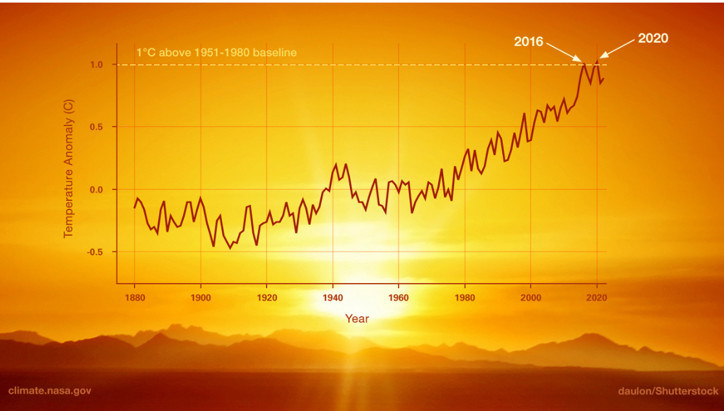

Fig 1: This graph shows a very high rate of warming, with 2020 tying with 2016 as the hottest year on record.[5]

* **Energy Absorption's role**

Increased GHG levels enhance heat absorption in the atmosphere, affecting surface temperatures and regional climate systems.[5][8]

* **Temperature Increases Across Regions**

The global temperature records show that all continents and oceans have warmed up, though at different rates, which is due to several factors including changes in land use, which modifies the amount of solar energy absorbed by the earth.[6]

1. **Earth's Energy Budget**

The Earth's energy budget refers to the movement of energy within the climate system. Since at least 1970, the climate system has been absorbing surplus energy as a result of a continuous disparity in energy flows.

The Earth is constantly exposed to substantial quantities of energy daily, primarily in the form of sunlight. Clouds, aerosol particles, and highly reflective surfaces such as snow and ice can reflect approximately one-third of the sun's rays into space. The remaining energy is absorbed by the land, sea, ice, and atmosphere. The primary factor responsible for the overall temperature change is the ocean's exceptional capacity to absorb heat, accounting for a significant 91% contribution. Earth's climate has changed over the industrial period, as manifested by increased global surface temperature and rising sea levels.

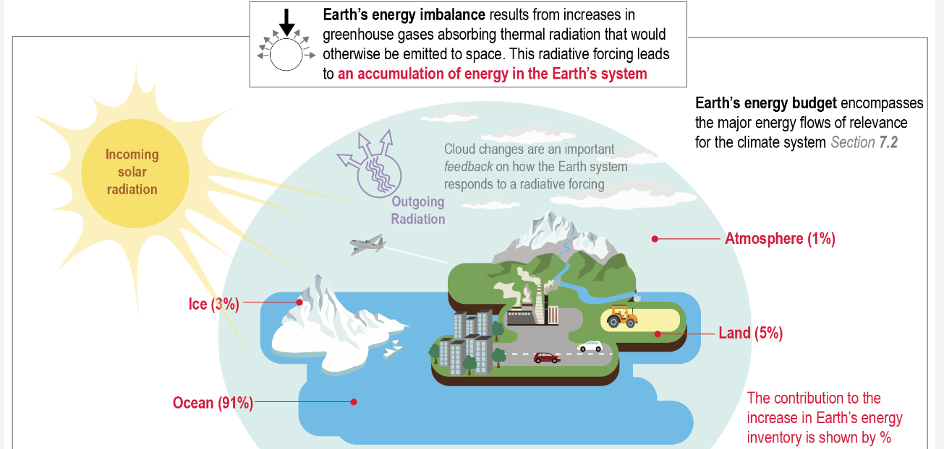

Fig 2: The graph shows that most of the excess energy due to the GHG effect is stored in the ocean, followed by land, ice, and the atmosphere**.[7]**

* 1. **Incoming and Outgoing Radiation**

The Earth absorbs incoming solar radiation in the form of longwave radiation and re-emits it as shortwave radiation. Clouds, atmospheric particles, and Earth's surface reflect 30% of incoming radiation, while the remaining 70% is absorbed, causing the Earth to warm**.**

* **Outgoing Longwave Radiation**

The Earth releases longwave radiation to maintain energy equilibrium. Every object, including the Earth, releases energy because of its temperature.[7][10]

* 1. **Role of the Atmosphere and Surface**

Absorption and Emission The atmosphere and Earth's surface assimilate, deflect, and discharge radiation. The surface is heated by solar energy, causing the air above it to warm up, and both emit longwave radiation.[8]

* **Reflection:** Clouds and atmospheric particles could reflect a portion of the solar radiation that reaches the Earth's surface, which is referred to as albedo. Surfaces with high albedo, such as ice and snow, reflect a greater amount of sunlight compared to darker surfaces like forests and oceans.[9]
* **GHG Effect** is the process in which GHG, such as carbon dioxide, methane, and water vapor, trap and re-radiate outgoing longwave radiation, thereby sustaining a livable climate on Earth.

1. **Incoming solar radiation**

Solar radiation is absorbed in the form of heat energy on Earth's surface and the atmosphere, influencing climatic and weather phenomena. Surface properties and atmospheric conditions affect absorption, with high albedo causing cooling and low albedo causing warming. Clouds also impact radiation balance, reflecting and absorbing it. Earth's inclination and trajectory affect solar radiation, affecting climate patterns. The Earth releases absorbed solar energy as longwave radiation, partially captured by greenhouse gases, contributing to the GHG effect. [2][5][3][8]

Fig 3: This graph shows the global mean energy budget of the Earth with and without clouds, highlighting the magnitudes and uncertainties of energy components, and quantifying cloud effects on the energy budget.[7]

* 1. **Impact of Incoming Solar Radiation on Climate and Energy Budget**
* **Longitude and latitude effects:** locations at different latitudes experience varying solar intensities due to the angle at which sunlight strikes the Earth's surface.
* Near the Equator: Sunlight hits at a steep angle, leading to intense radiation and efficient warming.
* Near the Poles: Sunlight hits at an oblique angle, resulting in less intense radiation.
* **Seasonal Variations**
* Tilt and Orbit: The Earth's axial tilt and elliptical orbit cause seasonal changes in solar radiation, affecting global climate patterns.[12][13]
  1. **Climate system as heat engine**

The climate system functions as a massive planetary heat engine, powered by solar radiation absorption and cooled by space emission. Heating occurs on warm tropical surfaces, while cooling occurs in colder troposphere's, primarily at higher latitudes.[10]

Fig 4: This graph shows how the Sun provides energy, which is partly used to drive natural processes on Earth, with the rest radiated back into space.[7]

1. **Available Data**

**Key Factors and Analysis in Solar Energy Absorption**

It is well known that the solar radiation significantly influences on many climatic parameters. Feedback of several of them includes effect on the solar radiation absorption/reflection properties. To comprehend these interactions and ascertain the most effective measurement techniques, we have opted for the ERA5 dataset and thermophysical property data from CoolProp. ERA5 provides extensive data on all pertinent variables for the previous decade, encompassing every month and hour of the day. while the thermodynamic and transport properties data of various substances are highly accurate as filled by CoolProp.

We have chosen crucial variables to comprehend those complex interrelationships among solar energy, atmospheric phenomena, and climate feedback mechanisms. [2] [5[6][11][14][24]

* 1. **Key parameters solar data and Climate Feedback**
     1. **Solar and Atmospheric Energy**
* **Solar irradiance:** Solar irradiance, the power received from the Sun per unit area, significantly influences Earth's energy balance and climate. It varies due to Earth's orbit, solar activity, and atmospheric composition, affecting climate patterns and local weather. Understanding surface solar irradiance is crucial for analyzing energy transfer between the atmosphere and land/ocean surfaces [2][7][14]
* **Solar radiation:** Solar radiation in Earth's energy budget involves absorption, reflection, and re-emission by surface and atmosphere. This balance, crucial for temperature regulation, is influenced by greenhouse gases, clouds, aerosols, and surface albedo. Changes impact global and local climates, affecting temperature patterns, atmospheric circulation, and plant growth. [1][11][16]
* **Temperature:** The Temperature, key for climate change assessment, reflects conditions experienced by humans and ecosystems. It's sensitive to local and global climate factors. Changes affect agriculture, water resources, biodiversity, precipitation patterns, and extreme weather events. Even small average temperature increases can trigger significant climate system responses. [1][4][5][6]
* **Incoming Solar Radiation:** amount of solar radiation reaching the top of the Earth's atmosphere, before it interacts with clouds or aerosols.
  + 1. **World Ocean**
* **Albedo:** Albedo measures the degree to which Earth's surface reflects light, thereby impacting the quantity of solar energy that is absorbed. Changes in albedo, resulting from the melting of ice or changes in land use, have the potential to greatly impact the overall global energy balance. Lower albedo means more solar energy is absorbed, leading to higher surface temperatures. [3][6]
  + 1. **Atmospheric Dynamics and Climate Feedback**
* **Air pressure:** Air pressure is a fundamental and essential atmospheric parameter that has a significant impact on weather patterns and the dynamics of climate. Changes in atmospheric pressure generate wind patterns and impact the development and direction of weather systems. Lower air pressure typically leads to stormy weather, while higher pressure often results in calmer conditions.
* **Clouds and Humidity:** Humidity, or the amount of water vapor in the air, is a key factor in cloud formation Clouds have a significant impact on the Earth's energy balance. They reflect certain amounts of the solar radiation back into space, which helps to cool the Earth. However, they also trap heat in the atmosphere, which contributes to global warming. The quantity and nature of cloud cover directly influence the absorption of energy at both local and global scales. [7]

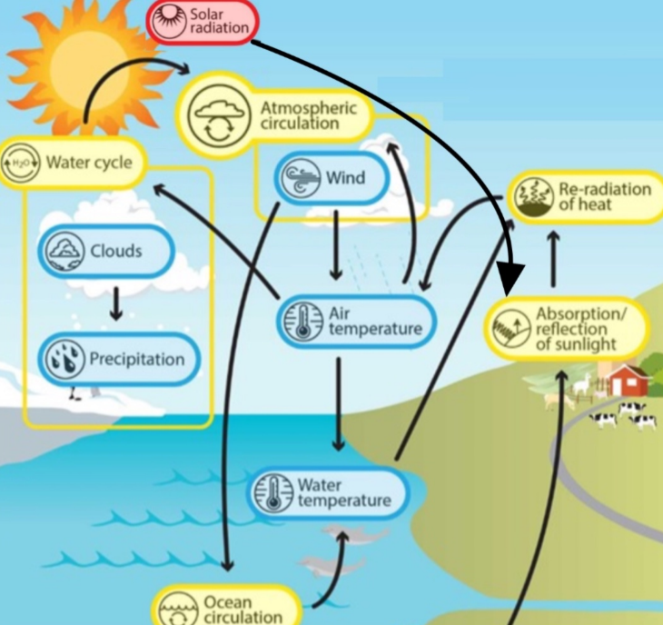

Fig 5: The graph shows how these parameters collectively influence the Earth's energy balance, climate patterns, and weather systems.[12]

* 1. **Existing Data integration and modeling**
* **Numerical models:**
* Using data sets to develop models that predict
* effect of solar radiation and water absorption on the climate.
* combines improved estimates of ocean heat content and climate scenarios [16].
* **Climate change models:**
* Climate Change Models focus on monitoring OHC and EEI to gain a precise picture of climate dynamics.
* Using integrated water and solar data to simulate future climatic scenarios.
* Verifying geodetic estimates by comparing them with Argo data and CERES observations. [11][15]
* **Thermodynamic models:**
* Thermodynamic models are used to estimate the EEI to gain a better understanding of global warming.
* Assessing variations in OHC.
* Estimating the changes in sea level caused by the expansion of water due to changes in temperature and differences in salt.
* Enhancing climate forecasts through the integration of many data sources.
* Using space-based methods to monitor the heat content of the ocean and the imbalance of energy on Earth.[11]
* **Error Propagation and Uncertainty Calculation:**
* Using data obtained from satellites to observe changes in sea level and ocean mass.
* Quantifying inaccuracies in the time series of GMSL and GMOM.
* Utilizing error propagation to estimate uncertainty in OHC and EEI.
* Using statistical techniques to determine the level of uncertainty in measurements of heat content.
* Using precise algorithms and implementing bias corrections to ensure the accuracy of climate modeling. [11][14]

1. **Research process**

We started the work process on the project by downloading ERA5 data. The required parameters were selected, a data request was submitted and approved, and the dataset was provided in GRIB format.

This format required specialized tools and libraries for decoding and processing. The data was then uploaded to a cloud drive for easy access in Google Colab, where it was converted to CSV format and processed using the necessary libraries for data extraction and analysis.

* 1. **Earth division and Area calculation:** The Earth is divided into grid squares based on 5-degree latitude increment. Since the Earth is spherical in shape two important considerations were kept in mind:
* Latitude Variation: The length of each latitude band decreases as it approaches the pole
* Longitude Width Dependence: The width of each grid square varies with latitude due to the converging meridians

To simplify the calculations, we calculated the area of one representative square per latitude level. Since each data point was assigned to a corresponding latitude level, it was sufficient for energy accumulation estimates to perform a single area calculation per level.

* 1. **Energy Absorption Calculation:** After the Earth was divided into grid squares and data points were assigned to their appropriate latitude level of granularity, at each point, we calculated the energy absorption by two independent methods:
* Atmospheric Heat Capacity Estimation
* Solar Radiation and Albedo Analysis

These equations thus enabled us to compare the two solutions to find out if they gave consistent results on energy absorption.

* 1. **Purpose of the comparison:** This was a necessary comparison since there were some uncertainties in the energy calculation techniques. The assessment of the two methods helped us understand how atmospheric heat capacity was related to the dynamics of energy absorption based on radiation. The consistency between these approaches ensured the reliability of our energy absorption estimates.
  2. **Data Processing:** To facilitate data extraction and analysis, we developed custom code that iterated through the Earth's surface, retrieved parameter values for specific locations and time points, and converted the raw data into CSV format in Google Colab. A custom C++ program was used to associate each data point with its corresponding grid on the Earth's surface. The processed CSV files served as the foundation for subsequent calculations and analysis.
  3. **Validation and Results**: The comparison of the two methods provided valuable insight into energy absorption dynamics and further emphasized the need for refinement of the tool. Results obtained were logical and according to expectations but not fully accurate for several reasons, which we would like to explain later.
  4. **Final Energy Calculation:** We calculated the energy at every point in the Earth's core, and the overall results were obtained by calculating the accumulated energy. In this regard, we averaged the energy at each latitude level and multiplied it by the area of that level. This method gave full representation of energy accumulation over a finite area in the Earth's core. After this calculation, we processed the results in Excel, creating graphs to visualize energy distribution over different regions. This allowed us to analyze variations in energy absorption and identify key trends in the data.

1. **Dataset**

Our dataset combines climatic parameters from ERA5 and thermophysical property data from CoolProp. We extracted 5 years of data from it, which returned very high-resolution records for every month and at every hour of the day. ERA5 is quite an exhaustive repository of atmospheric and climatic data, while the thermodynamic and transport properties data of various substances are highly accurate as filled by CoolProp. All these datasets together enable us to study the interaction of solar radiation and climatic variables in view of their impact on absorption, reflection, and thermophysical properties, which will support us in evaluating effective measurement techniques for climate dynamics.

* 1. **Parameters from** **ERA5**:
* **OLR:** Mean Top Net Longwave Radiation Flux

It directly represents the outgoing longwave radiation leaving the top of the atmosphere.

* **STR:** Surface Net Thermal Radiation

This represents the balance of thermal radiation at the Earth's surface.

* **SSRD:** Surface Solar Radiation Downward

This parameter measures the total solar radiation reaching the Earth's surface, which is essential for calculating the absorbed solar energy.

There are multiple datasets in ERA5 that can represent each parameter in the formula, but we carefully selected those most relevant to accurately quantify energy absorption and radiation dynamics. To ensure accurate calculations.it has been decided that data for overcast skies or overcast weather would be applied in the methodology because using clear sky data would amount to doing unnecessary work since the presence of clouds had already been catered for with the TCC parameter. Any effort made to do that would have made results inconsistent to retain critical impacts due to the cover created by clouds.

* **TCC:** Total cloud cover

Is a single level field calculated from the cloud occurring at different model levels through the atmosphere.

* $α$**:** Forecast albedo

Refers to the predicted fraction of solar radiation reflected by the surface under forecasted atmospheric and surface conditions.

* **Temperature:**
* **2m Dew Point Temperature** represents the temperature at 2 meters above the surface at which air becomes saturated with moisture, leading to condensation.
* $∆T$**:**2m Temperature – 2m Dew Point Temperature represents the air temperature at 2 meters above the Earth's surface.
* **Surface pressure:** represents the atmospheric pressure at the Earth's surface.
  1. **Parameters from** **COOLPROP**
* **C: Heat Capacity**

Represents the amount of energy required to raise the temperature of a unit mass of a unit mass of humid air.

* **Humidity: HAPropsSI**

Represents the moisture content in the air.

1. **Energy Absorption: Methods and Data Processing**

Our study utilized ERA5 dataset parameters and thermodynamic calculations to analyze energy absorption at specific points on Earth's surface. This section describes in detail the methodology formulas and data processing steps that were used in our research.

* 1. **Methods**:
     1. **Solar Radiation and albedo analysis Based Method:**

The solar radiation-based method considers multi-atmospheric and surface parameters for the estimation of total absorbed solar radiation. Each part of this equation represents a different factor affecting solar radiation absorption.[31][38]

$$\left|STR\right|-OLR+(TCC-1)×cos⁡θ×(1-α)×SSRD=E$$

**Breaking down each part of the formula:**



$\left|STR\right|-OLR$

The subtraction of OLR from STR isolates the net longwave energy exchange at the surface. This step is important for calculation how much heat escapes into space and how much remains near the surface. Since OLR in ERA5 is already negative the subtraction effectively adds its absolute. [40]

We take the absolute value of STR to ensure it is representing total available surface energy [28] instead of just net.



$\left(TCC-1\right)$

Since cloud cover reduces the amount of solar radiation reaching the surface, subtracting 1 adjusts TCC to represent its net impact on radiation absorption.[39]

$\cos{θ}= \sin{ϕ }\sin{δ} + \cos{ϕ }\cos{δ}\cos{h}$

Reflects how the sun’s angle affects the intensity of solar radiation on the surface.

θ = solar zenith angle (in degrees),

ϕ= latitude of the observer (in degrees),

δ = solar declination angle (in degrees),

h = hour angle (in degrees).[34]

1. **Solar Declination Angle (δ)**

$δ={23.45}^{ο} \sin\left[\frac{360}{365}× \left(284+n\right)\right]$

Where:

δ = solar declination angle (in degrees)

* **n**: Day of the year (n=1 corresponds to January 1)

This is calculated using: $n=\left\lfloor \frac{time_difference}{1440}\right\rfloor +1$

Where:

**time difference**: Total minutes since the start date.

1440 Number of minutes in a day

We added +1 to the formula for the day of the year n to ensure that the first day starts from 1 instead of 0*.*

1. **Hour Angle**

$h= {15}^{ο}*\left(Local solar time-12\right)$

**local time:** The time in hours at the given location, calculated using: $local time=(time difference/60) mod 24$

Where:

Divide the time difference (in minutes) by 60 to convert it to hours

Take the remainder (modulo 24) to ensure the time stays within a 0 to 23-hour range

This ensures that after 24 hours, the time resets to 0. [41]

$\left(1-α\right)×SSRD$

Represents the portion of solar radiation absorbed by the surface, considering reflectivity (albedo)

Multiplying by SSRD gives the total absorbed energy from solar.[31][39]

By integrating these parameters, this method provides an accurate calculation of the net solar energy absorbed by Earth's surface. Each element considers critical atmosphere-surface effects in such a way that the general formula may also be applied under different locations or seasonal variations.

* + 1. **Atmospheric heat capacity estimation-based Method:**

This method considers multiple atmospheric and surface parameters to estimate the total energy absorbed or released due to temperature changes. Based on specific heat capacity, temperature variations, and surface area considered.

$$E=AREA×C×∆T$$

**Breaking down each part of the formula:**

* **AREA:** represent the geographical area of the grid cell where energy absorption is calculated.

We use area instead of volume [43] because we are calculating heat absorption at the surface rather than within the atmosphere.

Surface based energy absorption is dominant as the ground retains more heat compared to the atmosphere.

* $∆T$: represent the temperature variation over given time interval.

A positive $∆T$ means heat is absorbed while a negative $∆T$ indicates cooling or heat loss.

* **C (Specific Heat Capacity of the Surface Layer):** The specific heat capacity depends on the material composition of the surface.

When considering air-layer heat interactions, the heat capacity is derived from:

1. 2m Dew Point Temperature (to determine humidity)
2. Surface Pressure (to calculate air density)
3. Humidity (since water vapor alters heat capacity).

* The function **(HumidAir::HAPropsSI)** from **CoolProp** is used to compute dynamic heat capacity.

we did not explicitly include air density like the original formula [43] because CoolProp calculates specific heat capacity (c) as a mass-based property, inherently accounting for air density. Therefore, a separate density term is unnecessary in our energy absorption calculations.

1. **Results** 
   1. **Solar Radiation and albedo analysis Based Method**

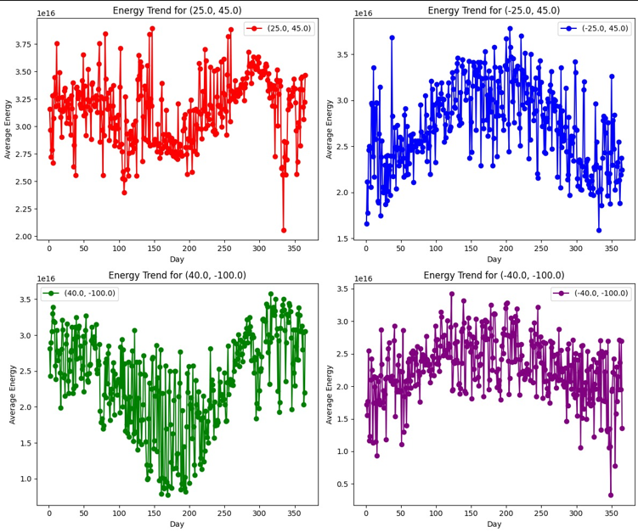

Fig 6: represent the average energy absorption in various Earth locations throughout a year **,** calculated using the radiation-based energy absorption equation. This approach considers solar radiation, cloud cover, albedo, and atmospheric conditions to determine how much energy is absorbed at each point.

Each pair of graphs represents two parallel locations, which simply means that they happen to be of the same longitude but oriented in opposite hemispheres of the world.

* + First Pair:
  + Red Graph → Middle East, Northeastern Saudi Arabia
* Blue Graph → Indian Ocean, Southeastern Madagascar
  + Second Pair:
* Green Graph → Central United States-Midwest Plains Northwest Region
* Purple Graph → Near Antarctica (Southwest Polar Region)
  + 1. **Why Do We See These Energy Absorption Trends?**
  + **Energy Peaks in Summer and Drops in Winter**
* The energy absorption is seasonal since solar radiation varies with intensity and day length.
* Locations in the Northern Hemisphere-for example, (40.0, -100.0) exhibit energy absorption during the mid-year months when they are more directly subjected to solar radiation.
* The Southern Hemisphere-for example, (-25.0, 45.0) peaks during December-January**.**
  + **Solar Radiation Drives Energy Variability**
* The formula involves SSRD, or Surface Solar Radiation Downward, and thus energy uptake is directly proportional to the solar radiation reaching the surface.
* Regions with higher solar exposure (lower cloud cover, low albedo) exhibit stronger energy absorption trends.
  + **Energy Absorption is Higher Near the Equator**
* Tropical and subtropical regions absorb more energy throughout the year because:
* They receive higher solar radiation
* Have higher humidity, increasing the greenhouse effect.
* Experience less seasonal variation, maintaining consistent high energy levels.
  1. **Atmospheric Heat Capacity Estimation**

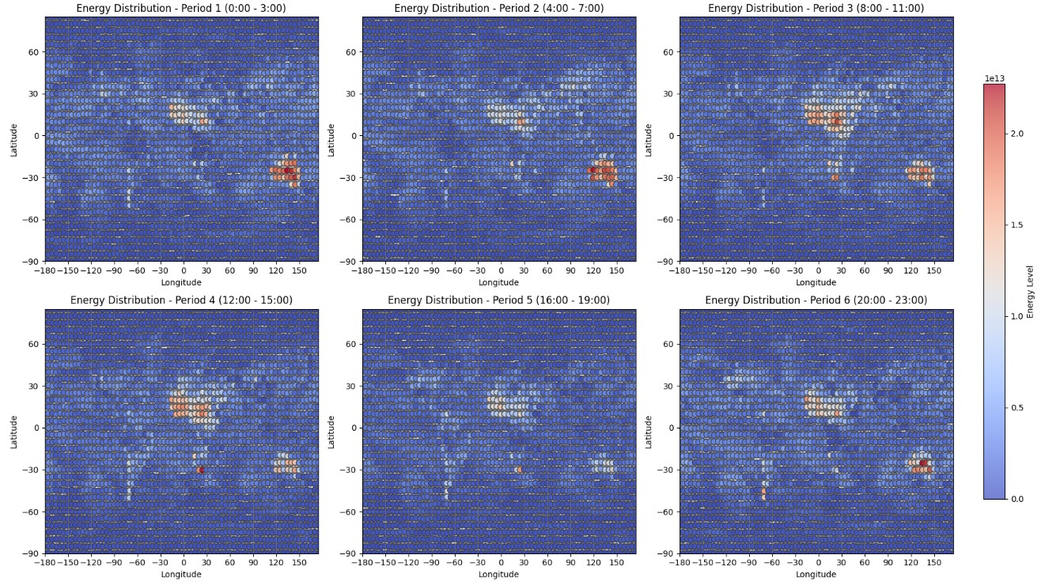

Fig 7: represent global energy absorption results based on Atmospheric Heat Capacity Estimation for a single day, divided into six time periods. Each point on Earth reflects how much energy is absorbed depending on temperature variations, humidity, and surface properties.

1. **Red/Orange areas** representing **high energy absorption**.
2. **Blue areas** indicating **low energy absorption**.
   * 1. **Why Is Energy Absorption High in These Locations?**
   * **Energy is Concentrated in the Middle of the Earth (Tropics and Subtropics)**

* The highest energy absorption appears near equatorial and tropical regions.
* This is because solar radiation is strongest at the equator, leading to higher temperature variations ΔT and more heat retention in the atmosphere.
  + **Heat Capacity is Higher in Humid Regions**
* The specific heat capacity of air is influenced by humidity.
* Moist air retains more heat, which is why energy absorption is higher in areas with high humidity (like tropical regions).
* Drier areas and deserts absorb less heat, as air with lower moisture content has a lower heat capacity.
  + **Energy Peaks During Midday and Declines at Night**
* The third and fourth periods (8:00 - 15:00) show the highest energy levels, aligning with peak solar radiation times.
* As the day progresses, energy levels decrease, following the natural cycle of heating and cooling.
* Nighttime periods (Period 1 and Period 6) show lower energy absorption, as the surface and atmosphere release stored heat.
* Land Absorbs
* The hotspots in the image appear mostly over land, because land surfaces heat up and cool down.
  1. **Comparison of Energy Absorption Methods**

The radiation based method reflects energy absorption that is both widespread and continuous in nature, with energy mostly being absorbed over large areas, especially near the equator and tropics where the solar radiation is strongest. This reflects a direct influence of solar radiation, cloud cover, and surface properties on gradual variations of energy absorption across different latitudes.

While the heat capacity method presents more concentrated energy absorption, instead of a smooth distribution, energy absorption is concentrated in selected areas where large temperature variations, humidity, and surface properties induce significant heat retention. Compared with the rather obvious tropics' center of highest absorption shown by the radiation-based method, an equatorial peak does not form in the heat-based one. Instead, this appears as heat absorption in isolated areas, depending on the time variability of atmospheric and surface heat retention. This difference arises because the radiation-based method directly responds to solar input, while the heat capacity method captures a longer-term accumulation and release. Radiation-based absorption therefore shows daily and seasonal solar cycles, whereas heat-based absorption brings forth regions with strong heat retention, like areas with high humidity and some land surfaces.

1. **The models**
   1. **Software Building Blocks and Data Flow**

This diagram illustrates a streamlined software architecture designed for energy absorption analysis. The system comprises several interconnected modules that handle data acquisition, processing, calculation, and visualization.

* **Data Acquisition Module**:
  + Responsible for obtaining raw GRIB data
  + Decodes the GRIB format into a usable form for further processing
  + Outputs decoded data to the Data Processing Module
* **Data Processing Module:**
  + Receives decoded data from the Data Acquisition Module
  + Performs necessary data cleaning, formatting, and preparation
  + Outputs processed data ready for calculations
* **Calculation Engine**: The Calculation Engine is the core of the system, consisting of two main components:
  + Heat Capacity Calculation:

Utilizes processed data to compute energy absorption based on atmospheric heat capacity.

Shares results with the Analysis and Visualization Module.

* + Solar Radiation Calculation:

Solar Radiation Calculation

Uses processed data to determine energy absorption based on solar radiation and albedo.

Shares results with the Analysis and Visualization Module.

* **Analysis and Visualization Module**:
  + Receives results from both calculation methods.
  + Performs comparative analysis between the two calculation approaches
  + Generates visual representations of the results.
  + Prepares final output for user interpretation.
  1. **Work Flow Diagram**

This flow chart displays the workflow for processing ERA5 climate data, mapping points, performing energy absorption calculations, and generating visual outputs.

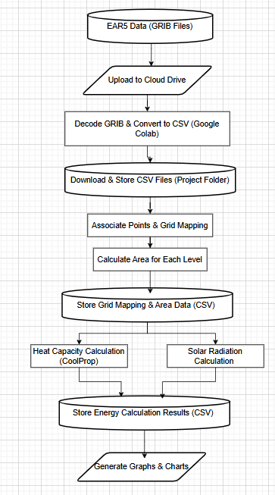

* **Data Acquisition & Storage**:
  + ERA5 Data (GRIB Files): Downloaded from ERA5 and uploaded to Google Drive.
  + Decoding & Conversion: GRIB files are processed in Google Colab and converted to CSV format.
  + Storage: CSV files are downloaded and stored in the project folder.
* **Grid Mapping & Area Calculation**:
  + Point Association: Data points are mapped to a grid.
  + Area Calculation: The area for one representative unit per latitude level is computed.
  + Storage: Results are saved as CSV files.
* **Energy Absorption Calculation**:
  + Heat Capacity Method (CoolProp): Uses air heat capacity for absorption calculations.
  + Solar Radiation Method: Computes absorption based on solar input and albedo.
  + Storage: Calculation results are saved in CSV format.
* **Output Generation**
  + Graphs & Charts: The processed data is visualized to compare both calculation models.

1. **Test plan**
   1. **Technical Test: Data Validation**

It is crucial to do technical checks to verify that the system accurately reads, processes, and produces the data used for our study. The tests mainly assess the operational aspects of data management and the proper functioning of the software components responsible for reading and verifying the data. To establish a dependable basis for future algorithmic evaluations, the main goal is to verify that the data is read accurately, and the functions execute effectively.   
The purpose of these tests is to verify the accuracy, completeness, and proper formatting of the data that is entered into the system. We shall undertake:

* DATA validation checks verify the accuracy of data reading and detect any faults, such as missing numbers or inappropriate formats. Consistency checks guarantee the stability of the data when it is read many times.
* We conduct function output validation to verify that certain functions responsible for handling and displaying data generate accurate outputs. This involves verifying the precision of generated summaries and statistical calculations by comparing them to expected values.
* The results of all tests will be thoroughly documented, including the specific items evaluated, the anticipated outcomes, and the actual findings, therefore ensuring full record of the system's performance.
  1. **Algorithm Logic Test: Energy Absorption Correlation**

As it is impossible to directly verify our approach's accuracy, we shall conduct some evaluations. These assessments will include tests to determine the credibility of the results.

The reliability assessment phase of the testing process is examining the results generated by our equations to verify their alignment with anticipated behaviors and established scientific concepts about energy absorption These assessments will function as an indirect verification of our method, guaranteeing that the findings are not only internally coherent but also credible within the wider framework of climate research.

* Given the difficulty of directly validating the accuracy of our complex algorithms, we will be involved in logical validation to verify the reasoning behind the obtained results. This incorporates the evaluation of whether our equations accurately represent the anticipated correlations among climate variables. We shall employ precise mathematical equations to

evaluate these correlations and ensure they meet scientific standards.

* **File Accessibility & Content Check** Verify that files open correctly, are not empty, and contain structured data.

1. **Challenges**
   1. **Data Downloading Issues**

* ERA5 only supports Python, making large file processing slow and incompatible with other languages.
* Downloading all 10 required parameters or more took significant time.
* ERA5 Data Requests**:** The request process itself takes time before the data is available for download.
  1. **Data Inaccuracy and Gaps**
* **ERA5 Database:**
* Missing data for the North Pole.
* Solar radiation parameters were cumulative (only available for 6 AM and 6 PM) instead of hourly data.
* Some parameters were unavailable for certain locations.
* **CoolProp Database:**
* Heat gain values were not normalized, leading to inaccuracies.
  1. **Calculation Difficulties**
* **Heat Gain Deviation:**
* Required volume measurements of locations, which were difficult to obtain.
* Lack of available data for these measurements.
* **Parameters in the formula:**
* Cloud coverage needed to be factored in.
* Multiple ERA5 parameters needed validation and alignment for accurate calculations.
* Extensive research was required to ensure parameter relevance and accuracy.
  1. **Data Comparison and Accuracy Issues**
* No way to fully validate the correctness of the data
* Impossible to verify accuracy across all global locations.
  1. **Difficulties with CoolProp Database**
* Downloading data and accessing files was challenging.
  1. **ERA5 Database Limitations**
* Could not download data for more than one year in a single file.

1. **Approaching challenges**
   1. **Solar Radiation Parameter Processing**

* Developed a C++ code to distribute energy unevenly and disperse it, factoring in the recorded value and dividing it by missing hours.
* Updated the code to automatically skip parameters that are not related to time.
  1. **Volume vs. Area in Energy Absorption**
* Switched from volume to area-based calculations.
* Implemented a grid-based approach to divide the Earth into squares at different levels.
  1. **Data Downloading Issues (ERA5)**
* Downloaded ERA5 data year by year to manage file size.
* Developed a more efficient process for handling Python limitations and improving speed.
  1. **Data Inaccuracy and Gaps**
* Implemented a data interpolation method to estimate missing hourly solar radiation values.
* Created a mechanism to handle missing data in specific locations
  1. **Calculation Difficulties**
* Shifted to area-based calculations for energy absorption.
* Developed cloud coverage correction factors in the calculations.
  1. **CoolProp Database**
* Streamlined file processing and optimized access mechanisms.
  1. **ERA5 Database Limitations**
* Implemented batch processing by downloading one year at a time.

1. **Conclusions**

* We investigated how changes in energy in one place can affect other areas.
* We investigated factors that affect reflected, absorbed, and re-emitted energy, including albedo, surface properties, and atmospheric conditions.
* We studied the angles and radiation of the sun and learned formulas related to the angles of the sun's rays and their effect on the absorption of solar energy.
* We reviewed existing models and solutions for understanding energy
* We found a comprehensive database of relevant data, models, and formulas to help build our simulation tools.
* We have summarized articles and educational resources about solar radiation, energy absorption, and their effects on climate change.
* We found combined datasets from ERA5 and CoolProp to accurately model real-world environmental conditions.
* We conducted an in-depth literature review to inform model development and validate our approach.
* We applied two methods radiation based absorption and heat capacity estimation comparing their results to assess accuracy and consistency.
* The results showed that radiation-based absorption is more universal, while the heat capacity-based absorption is more local, reflecting different aspects of energy storage and transfer.
* Our research helps enhance climate forecasting and the prediction of extreme weather further by explaining the linkage between energy absorption and climate patterns.

1. **References:**

**[1]: Rawat, A., Kumar, D., & Khati, B. S. (2024). Climate change impacts on different sectors: A systematic approach. Journal of Water and Climate Change, 15(1), 104-109.**

**[2]:** [Absorption / reflection of sunlight - Understanding Global Change (berkeley.edu)](https://ugc.berkeley.edu/background-content/reflection-absorption-sunlight/)

[3]:[Snow/Ice Albedo | Earthdata (nasa.gov)](https://www.earthdata.nasa.gov/topics/cryosphere/snow-ice/snow-ice-albedo)

[4]: Zogas A, Kosman E, Sternberg M (2020) Germination strategies under climate change scenarios along an aridity gradient. J Plant Ecol 13:470–477: [Germination strategies under climate change scenarios along an aridity gradient | Journal of Plant Ecology | Oxford Academic (oup.com)](https://academic.oup.com/jpe/article/13/4/470/5864758)

[5]: [What Is Climate Change? | Facts – Climate Change: Vital Signs of the Planet (nasa.gov)](https://climate.nasa.gov/what-is-climate-change.amp)

[6]: [6 charts explaining climate change that everyone should see | World Economic Forum (weforum.org)](https://www.weforum.org/agenda/2021/11/climate-change-causes-science-global-warming/)

**[7]:** [**https://www.ipcc.ch/report/ar6/wg1/chapter/chapter-7/**](https://www.ipcc.ch/report/ar6/wg1/chapter/chapter-7/)

**[8]:** [**https://journals.ametsoc.org/collection/earths-energy**](https://journals.ametsoc.org/collection/earths-energy)

**[9]:** [**https://agupubs.onlinelibrary.wiley.com/doi/full/10.1029/2008RG000275**](https://agupubs.onlinelibrary.wiley.com/doi/full/10.1029/2008RG000275)

**[10]:** [**https://pubs.aip.org/physicstoday/article/75/7/30/2848581**](https://pubs.aip.org/physicstoday/article/75/7/30/2848581)

**[11]:** [ESSD - Monitoring the ocean heat content change and the Earth energy imbalance from space altimetry and space gravimetry (copernicus.org)](https://essd.copernicus.org/articles/14/229/2022/)

**[12]:** [**https://ugc.berkeley.edu/background-content/atmospheric-circulation/**](https://ugc.berkeley.edu/background-content/atmospheric-circulation/)

**[13]:** [**https://ugc.berkeley.edu/background-content/earths-spin-tilt-orbit/**](https://ugc.berkeley.edu/background-content/earths-spin-tilt-orbit/)

**[14]:** [Frontiers | Measuring Global Ocean Heat Content to Estimate the Earth Energy Imbalance (frontiersin.org)](https://www.frontiersin.org/journals/marine-science/articles/10.3389/fmars.2019.00432/full)

**[15]:** [OCEAN5: The ECMWF Ocean Reanalysis System and its Real-Time analysis component | ECMWF](https://www.ecmwf.int/en/elibrary/80763-ocean5-ecmwf-ocean-reanalysis-system-and-its-real-time-analysis-component)

**[16]:** [Improved estimates of ocean heat content from 1960 to 2015 | Science Advances](https://www.science.org/doi/10.1126/sciadv.1601545)

**[17]:** [**https://papers.ssrn.com/sol3/papers.cfm?abstract_id=4669489**](https://papers.ssrn.com/sol3/papers.cfm?abstract_id=4669489)

**[18]:** [A Review on Evaluation Methods of Climate Modeling - ScienceDirect](https://www.sciencedirect.com/science/article/pii/S1674927813500219)

**[19]:** [**https://climate.copernicus.eu/climate-indicators/sea-surface-temperature**](https://climate.copernicus.eu/climate-indicators/sea-surface-temperature)

**[20]:** [**https://salinity.oceansciences.org/overview.htm**](https://salinity.oceansciences.org/overview.htm)

**[21]:** [**https://www.britannica.com/science/ocean-current**](https://www.britannica.com/science/ocean-current)

**[22]:** [**https://journals.ametsoc.org/view/journals/clim/32/17/jcli-d-18-0752.1.xml**](https://journals.ametsoc.org/view/journals/clim/32/17/jcli-d-18-0752.1.xml)

**[23]:** [**https://link.springer.com/article/10.1007/s40726-019-00107-6#Sec6**](https://link.springer.com/article/10.1007/s40726-019-00107-6#Sec6)

**[24]:** [**https://cds.climate.copernicus.eu/cdsapp#!/dataset/reanalysis-era5-single-levels?tab=form**](https://cds.climate.copernicus.eu/cdsapp#!/dataset/reanalysis-era5-single-levels?tab=form)

**[25]:** [CoolProp: Fluid properties for the masses — CoolProp 4.2.5 documentation](http://www.coolprop.org/v4/index.html)

**[26]:** [Blog: How to calculate distances between points with the Maps JavaScript API – Google Maps Platform](https://mapsplatform.google.com/resources/blog/how-calculate-distances-map-maps-javascript-api/)

**[27]:** [**https://pubs.acs.org/doi/10.1021/ie4033999**](https://pubs.acs.org/doi/10.1021/ie4033999)

**[28]:** [**https://cds.climate.copernicus.eu/cdsapp#!/dataset/reanalysis-era5-single-levels?tab=overview**](https://cds.climate.copernicus.eu/cdsapp#!/dataset/reanalysis-era5-single-levels?tab=overview)

**[29]: Lawrence, M. G. (2005). The relationship between relative humidity and the dewpoint temperature in moist air: A simple conversion and applications. Bulletin of the American Meteorological Society, 86(2), 225-234.**

**[30]:** [**https://www.researchgate.net/publication/376521669_Review_of_AI-Enhanced_Weather_Forecasting_Application_for_Communication_Networks**](https://www.researchgate.net/publication/376521669_Review_of_AI-Enhanced_Weather_Forecasting_Application_for_Communication_Networks)

**[31]:** [**https://open.oregonstate.education/climatechange/chapter/theory/**](https://open.oregonstate.education/climatechange/chapter/theory/)

**[32]:** [**https://www.pveducation.org/pvcdrom/properties-of-sunlight/solar-radiation-on-a-tilted-surface**](https://www.pveducation.org/pvcdrom/properties-of-sunlight/solar-radiation-on-a-tilted-surface)

**[33]:** [**https://www.sciencedirect.com/topics/engineering/hour-angle**](https://www.sciencedirect.com/topics/engineering/hour-angle)

**[34]:** [**https://en.wikipedia.org/wiki/Solar_zenith_angle**](https://en.wikipedia.org/wiki/Solar_zenith_angle)

**[35]:** [**https://www.sciencedirect.com/topics/engineering/solar-azimuth-angle**](https://www.sciencedirect.com/topics/engineering/solar-azimuth-angle)

**[36]:** [**https://pvpmc.sandia.gov/modeling-guide/1-weather-design-inputs/irradiance-insolation/extraterrestrial-radiation/**](https://pvpmc.sandia.gov/modeling-guide/1-weather-design-inputs/irradiance-insolation/extraterrestrial-radiation/)

**[37]:** [**Specific Heats (nasa.gov)**](https://www.grc.nasa.gov/www/k-12/airplane/specheat.html)

**[38]:**  [**Hendeson_Thesis_Final**](https://api.mountainscholar.org/server/api/core/bitstreams/d790a199-9ddf-4f13-bc8e-b3c1ca7342d1/content)

**[39]:** <https://www.jstor.org/stable/26242903?casa_token=7VmPLzzOElwAAAAA%3ArfQhNiNAXqiX009EzjZzySYG4DyG4sTez7G1Ra0abyumbumnwzj95fJDs8YKWDCIwuKuVIDSYzXBgyXYlAKx2r3O-spcQxPhIxgEuLTRRuuOqE7LxvXt&seq=1>

**[40]:** [**https://www.ecmwf.int/sites/default/files/elibrary/2015/18490-radiation-quantities-ecmwf-model-and-mars.pdf**](https://www.ecmwf.int/sites/default/files/elibrary/2015/18490-radiation-quantities-ecmwf-model-and-mars.pdf)

**[41]:** [**International Journal of Energy and Environment (IJEE)**](https://www.researchgate.net/profile/Akram-Al-Khazzar/publication/283051726_A_comprehensive_solar_angles_simulation_and_calculation_using_Matlab/links/5627952908aed9017d45f6dd/A-comprehensive-solar-angles-simulation-and-calculation-using-Matlab.pdf)

**[42]:** [**Section 10.2 Pg 375.pdf**](https://chalifoux.ca/ShepNet/Sci10/Sci10text/Chapter%2010/Section%2010.2%20Pg%20375.pdf?utm_source=chatgpt.com)